South German Credit Risk Analysis

1.Executive Summary:
In the banking sector, minimizing Non-Performing Assets(NPAs) is critical for profitability. Efficient credit risk management requires data-driven protocols to identify high-risk applicants before funds are distributed. This project addresses the challenge of distinguishing between creditworthy and non-creditworthy applicants to reduce default exposure.
Utilizing the South German Credit dataset, I developed a Logistic Regression model to predict default probabilities. The dataset, consisting of 1000 observations(700 Good / 300 Bad), was split into an 80% Training (n = 800) and 20% Testing (n=200) set via Simple Random Sampling. This approach allowed for the isolation of statistically significant risk drivers using Maximum Likelihood Estimation.
The model achieved an Area Under the Curve (AUC) of 0.80, demonstrating strong discrimination power. The analysis identified Checking Account Status and Credit History as the primary predictors of default. These insights provide a quantifiable framework for loan officers to automate approval decisions, focusing manual review resources only on borderline cases.
2.Introduction:
Credit risk-the risk of loss resulting from a borrower’s failure to repay a loan or meet contractual obligations is the single largest risk faced by commercial banks. Historically, loan approval decisions were based on the subjective judgement of bank officers. However, with the increasing volume of loan applications and the complexity of financial profiles, subjective methods are no longer scalable or consistent.
Modern banking relies on Credit Scoring Models to quantify this risk. By analyzing historical data, banks can assign a probability of default to each applicant. This project focuses on the South German Credit dataset, a corrected and standardized version of the classic German credit data. The analysis aims to transition from subjective assessment to a statistical framework, using Logistic Regression to mathematically identify the attributes (such as checking account status and credit history) that most strongly correlate with financial default.
2.1Objectives:
The primary goal of this project is to develop a robust statistical model to predict the creditworthiness of loan applicants. The specific objectives are as follows:
- Predictive Modeling: To build a Binary Logistic Regression model that classifies applicants into “Good” (Non-Default) or “Bad” (Default) categories with a target Area Under the Curve (AUC) of > 0.75.
- Risk Driver Identification: To determine which socio-economic variables (eg. Employment duration, savings, age) are statistically significant predictors of default using Maximum Likelihood Estimation.
- Policy Formulation: To interpret the Odds Ratios of significant variables and derive actionable business rules (eg. Specific rejection criteria for high-risk segments).
3.Data Description:
3.1 Data Source The analysis is based on the “South German Credit” dataset. This is a corrected and standardized version of the original German Credit data, curated by Professor Ulrike Grömping (2019) to rectify translation errors and inconsistencies found in earlier versions. The dataset contains financial and demographic information for 1000 loan applicants from a regional bank in Southern Germany.
3.2 Dataset Structure The dataset consists of 1000 observations and 21 variables (20 independent predictor variables and 1 dependent target variable).
- Target Variable: Default_Risk (Binary Classification)
  - Good Credit (Non-Default): 700 applicants (70%)
  - Bad Credit (Default): 300 applicants (30%)
- Imbalance Note: The dataset exhibits a 70:30 class imbalance, which is typical for credit risk scenarios where reliable customers outnumber defaulters.
3.3 Key Predictor Variables: The analysis focuses on a mix of qualitative and quantitative attributes to assess risk. The key variables utilized in the model include:
- Checking_Status: Status of existing checking account (eg. Overdraft, <200 DM, No Account).
- Credit_History : Past repayment behaviour (eg. Critical account, All credits paid back duly).
- Duration_Months: The duration of loan in months.
- Credit_Amount: The total amount of credit requested ( in Deutsche Marks).
- Age_Years: The age of the applicant in years.
4. Methodology:
4.1 Model Selection: Binary Logistic Regression The nature of the target variable, Default_Risk, is binary (1 = Good/Non Default, 0 = Bad/Default), which is why Binary Logistic Regression was selected as the modeling technique. Unlike Linear Regression, which fits a straight line and can predict values outside the range 0 to 1, Logistic Regression constrains predictions strictly between 0 and 1. This ensures that the output can be interpreted as a valid probability of default.
4.2 Mathematical Framework The model predicts the Log-Odds (Logit) of a customer being “Good”. The relationship is expressed as:
$ln(\frac{P}{1-P})= β_{0}+ β_{1}X_{1}+ β_{2}X_{2}+…+ β_{k}X_{k}$
Where
- P is the probability of the event (Default_Risk = 1)
- $β_{0}$ is the intercept.
- $β_{k}$ are the coefficients estimated by the model for each predictor variable ($X_{k})$.
4.3 Estimation Technique: Maximum Likelihood Estimation (MLE) To estimate the coefficients, the model utilizes Maximum Likelihood Estimation rather than Ordinary Least Squares (OLS). MLE is an iterative algorithm that adjusts the coefficients to maximize the likelihood that the predicted probabilities match the observed data (Good vs Bad) in the training set.
4.4 Model Evaluation Metrics The model’s performance was evaluated using the following statistical criteria:
- Akaike Information Criterion (AIC): Used to measure the relative quality of the model. A lower AIC indicates a better fit with less information loss.
- Odds Ratios: Calculated to quantify the strength and direction of the relationship between predictors and the likelihood of default.
- ROC Curve & AUC: The ROC plots Sensitivity vs 1-Specificity. The Area Under the Curve (AUC) serves as the primary metric for the model’s discriminatory power (ability to distinguish between defaulters and non-defaulters).
5. Results & Analysis:
5.1 Model Fit and Statistical Significance The model’s overall validity was assessed using the AIC and the Global Null Hypothesis test.
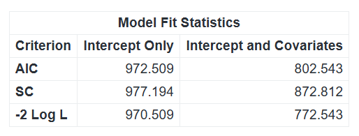
Figure 1: SAS Model Fit Statistics showing AIC reduction.
- AIC Reduction: The AIC value decreased significantly from 972.509 (Intercept Only) to 802.543 (Intercept + Covariates). This reduction of approximately 17.5% indicates that the selected predictor variables added substantial explanatory power to the model.
- Global Null Hypothesis: The Likelihood Ratio, Score, and Wald Chi-Square test all returned p-values of <0.0001. This confirms that the model as a whole is statistically significant and performs far better than random guessing.
5.2 Identification of Risk Drivers (Type 3 Analysis) Using the Type 3 Analysis of Effects, we evaluated which variables were statistically significant variables of default.
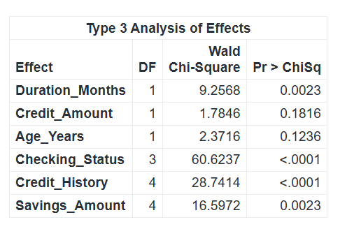
Figure 2:Type 3 Analysis identifying significant risk drivers.
- Significant Predictors (p < 0.05):
  - Checking_Status (p < .0001): The strongest predictor of risk.
  - Credit_History (p < .0001): Highly significant
  - Duration_Months (p = 0.0023): Loan term length significantly impacts default probability.
  - Savings_amount (p = 0.0023): Financial savings are a key indicator of safety.

- Non-Significant Predictors (p > 0.05):
- Credit_Amount (p = 0.1816) and Age_Years (p= 0.1236) were found to be statistically insignificant. This implies that in this specific dataset, a young applicant borrowing a large amount is not inherently riskier than an older applicant borrowing a small amount, provided their checking status and history are sound.
5.3 Interpretation of Odds Ratios (Risk Quantification) The Odds Ratios Estimates provide the quantifiable risk associated with specific customer segments.
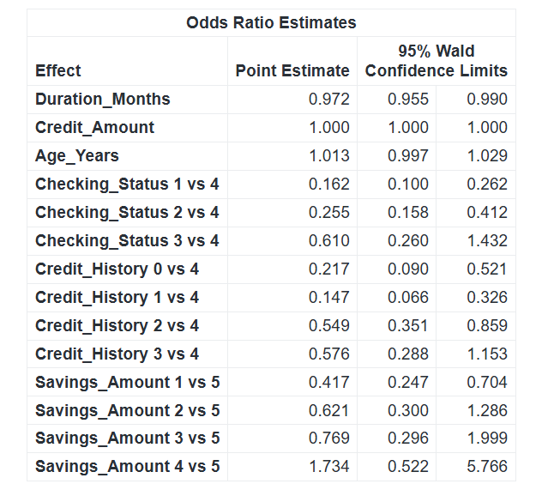
Figure 3:Odds Ratios quantifying the risk of Overdrafts and Critical Accounts.
- Checking Account Impact: Applicants with a negative checking balance (Status 1) have an Odds Ratio of 0.162 compared to those with no checking account. This indicates they are approximately 6 times more likely to default (Inverted Risk: 1/0.162 approx 6.1).
- Credit History Impact: Applicants with a “Critical Account” (History 1) have an Odds Ratio of 0.147, identifying them as the highest-risk segment.
- Savings Impact: Conversely applicants with rich savings (>1000 DM) showed a positive correlation with repayment, acting as a strong mitigating factor against default.
5.4 Model Performance:

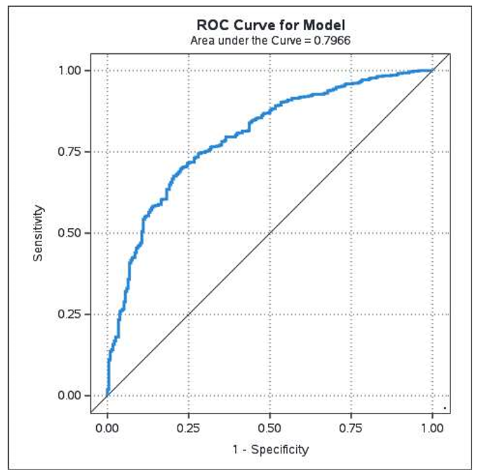
Figure 4:ROC Curve (AUC = 0.80) demonstrating model accuracy.
- ROC Curve & AUC: The model achieved an Area Under the Curve of 0.797 (approx 0.80). This indicates a strong professional-grade model capable of correctly distinguishing between a defaulter and a non-defaulter 80% of
the time.
6. Conclusion & Recommendations
6.1 Conclusion
This project successfully demonstrated the efficacy of Logistic Regression in quantifying credit risk. With an AUC of 0.80, the model provides a robust, scientifically validated framework for distinguishing between creditworthy and high-risk applicants. The analysis conclusively proved that a customer’s financial stability (Checking/Savings) and past behavior (Credit History) are far superior predictors of default than demographic factors like Age or loan characteristics like Credit Amount.
6.2 Strategic Recommendations
Based on the statistical findings, the following business strategies are recommended to minimize Non-Performing Assets (NPAs):
- Automated Rejection Policy: Applicants falling into Checking Status 1 (Overdraft) or Credit History 1 (Critical Account) should trigger an automatic high-risk flag. These segments carry a default probability ~6x higher than the baseline and should require senior officer approval to override.
- Streamlined Approvals for "Gold" Customers: Applicants with Savings > 1000 DM or a "Paid Back Duly" history should be fast-tracked. Their statistical risk is negligible, allowing the bank to reduce processing time and capture good business faster.
- Risk-Based Pricing: Since Duration is a significant risk factor ($p=0.0023$), the bank should consider implementing a risk premium (higher interest rate) for long-term loans (>24 months) to compensate for the increased probability of default.
- Periodic Model Recalibration: Given the dynamic nature of financial behavior, this model should be re-trained every 6-12 months using new data to ensure the coefficients remain accurate and reflective of current economic conditions.
7. Appendix: SAS Source Code
The following SAS program was executed to perform data cleaning, logistic regression modeling, and statistical validation.

/**********************************************************************
* PROJECT: South German Credit Risk Analysis
* AUTHOR: Nishant Pareek
* DATE: January 2026
* ALGORITHM: Binary Logistic Regression (Maximum Likelihood)
**********************************************************************/

/*1.Creating a Library*/
LIBNAME cr_risk "/export/viya/homes/2024btechaimlnishant17473@poornima.edu.in/german_bank";

/*2.Importing the data */
PROC IMPORT DATAFILE="/export/viya/homes/2024btechaimlnishant17473@poornima.edu.in/SouthGermanCredit.asc"
DBMS = DLM
OUT = cr_risk.german_credit
REPLACE;
DELIMITER = ' ';
GETNAMES = YES;
RUN;

/*3.Cleaning the data */
DATA cr_risk.renamed_credit;
SET cr_risk.german_credit;

/*Rename German variables to English Banking terms */
RENAME
laufkont = Checking_Status
laufzeit = Duration_Months
moral = Credit_History
verw = Purpose
hoehe = Credit_Amount
sparkont = Savings_Amount
beszeit = Employment_Duration
rate = Installment_Rate
famges = Personal_Status_Sex
buerge = Other_Debtors
wohnzeit = Residence_Duration
verm = Property
alter = Age_Years
weitkred = Other_Installment_Plans
wohn = Housing
bishkred = Number_Credits
beruf = Job_Type
pers = Liable_People
telef = Telephone
gastarb = Foreign_Worker
kredit = Default_Risk;
RUN;

/*3.Creating sample */
PROC SURVEYSELECT DATA = cr_risk.renamed_credit
OUT = work.model_data
METHOD = SRS
RATE = 0.8
SEED = 12345
OUTALL;
RUN;

/*4.Building the Model */
PROC LOGISTIC DATA = work.model_data DESCENDING PLOTS = ROC;
WHERE Selected = 1;

/*Categorical Variable */
CLASS Checking_Status Credit_History Purpose Savings_Amount
Housing Job_Type / PARAM = REF;
/*Equation*/
MODEL Default_Risk = Duration_Months Credit_Amount Age_Years Checking_Status Credit_History Savings_Amount;
RUN;

